**WEB MINING**

**HARSH TRIPATHI**

**16BCE1186**

**PAGERANK ALGORITHM**

**d = 0.85**

**size = outlinks.shape[0]**

**page_ranks = [1 for i in range(size)]**

**out_degrees =[ ]**

**for i in range(size):**

**sums = 0**

**for j in range(size):**

**sums += outlinks[i][j]**

**out_degrees.append(sums)**

**print('Initial page ranks:')**

**print(page_ranks)**

**for _ in range(100):**

**for j in range(size):**

**temp = 0**

**for i in range(size):**

**if outlinks[i][j] == 1:**

**temp += page_ranks[i] / out_degrees[i]**

**temp *= d**

**temp += (1-d)**

**page_ranks[j] = round(temp, 4)**

**return page_ranks**

**outlinks = [0, 1, 1, 1, 0, 1, 0, 1, 1, 0, 0, 0, 0, 1, 0, 0, 0, 1, 0, 1, 0, 1, 1, 1, 0]**

**outlinks = np.reshape(outlinks, (5, 5))**

**page_ranks = calculate_PageRank(outlinks)**

**print()**

**print('The converged page rank is:')**

**print(page_ranks)**

**print()**

**sums = 0**

**for i in page_ranks:**

**sums += i**

**print('The sum of page ranks is: ', round(sums, 4))**

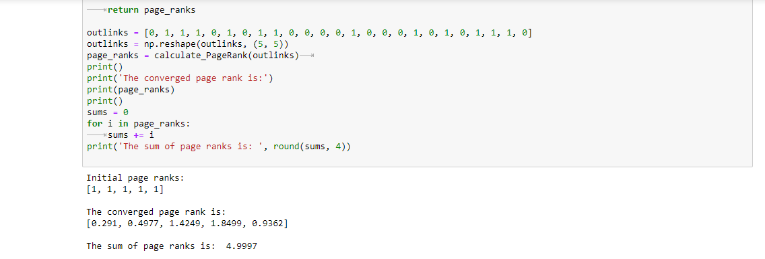

**HITS ALGORITHM**

**import numpy as np**

**size = outlinks.shape[0]**

**hub_scores = [1.0 for i in range(size)]**

**authority_scores = [1.0 for i in range(size)]**

**print(hub_scores)**

**for _ in range(100):**

**for j in range(size):**

**temp_auth = 0.0**

**for i in range(size):**

**if outlinks[i][j] == 1:**

**temp_auth += hub_scores[i]**

**authority_scores[j] = temp_auth**

**auth_sum = sum(authority_scores)**

**for i in range(len(authority_scores)):**

**authority_scores[i] /= auth_sum**

**for i in range(size):**

**temp_hub = 0.0**

**for j in range(size):**

**if outlinks[i][j] == 1:**

**temp_hub += authority_scores[j]**

**hub_scores[i] = temp_hub**

**return authority_scores, hub_scores**

**n = int(input('Enter the size of the matrix:\t'))**

**outlinks = []**

**for i in range(n*n):**

**temp = int(input('Enter the element:\t'))**

**outlinks.append(temp)**

**outlinks = np.reshape(outlinks, (n, n))**

**authority_scores, hub_scores = authority_hub_score(outlinks)**

**print("Authority Scores:")**

**for i in (authority_scores):**

**print(round(i, 4))**

**print("Hub Scores:")**

**for i in (hub_scores):**

**print(round(i, 4))**

